Celebration of Valentine’s Day 2020
Left to Right – Debi Cockburn, Janice and John Chandler,
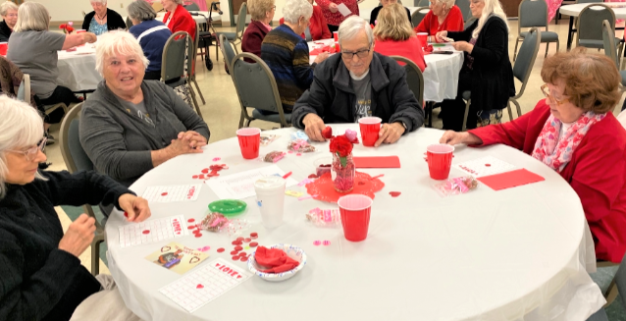

Left to Right – Richard ‘Dick’ Tinsley, LaVerne Renee and Pete Kincaid, Connie Pruitt, and Peggy Caldwell.
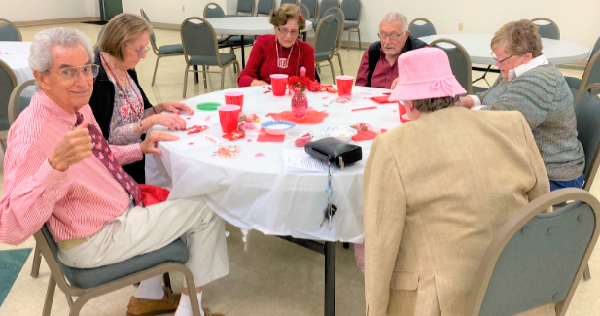

Left to Right: Linda Bell, Rose Harper, Shaun Black, Jackie Robb with friends
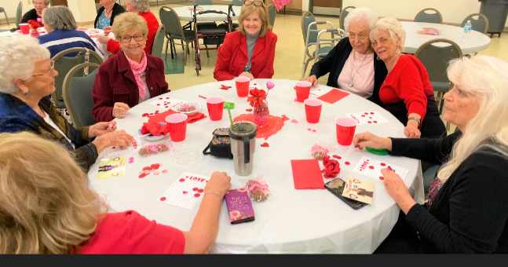

Silvia ‘The Queen’ Young has her Royal eyes on You this Valentine’s Day.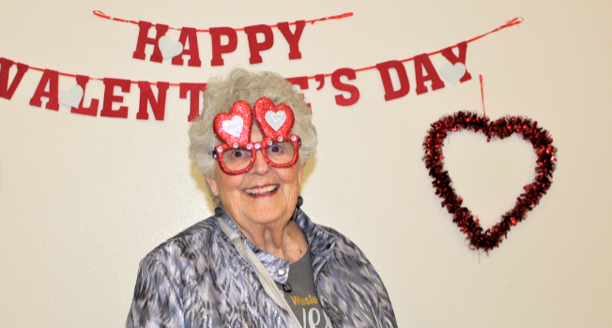

‘Smiley’ Pete with Renee Kincaid wearing Pete’s Top Hat! And Rene looks very happy about it.
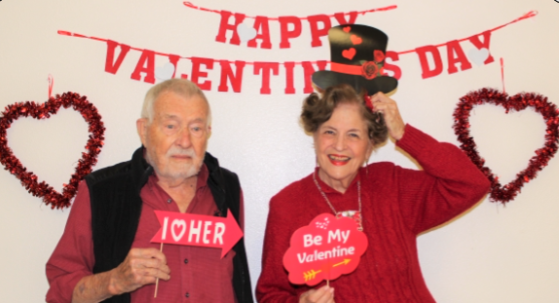

Southern Belle Fran Mobley in-between Happy Hearts Filled Marlen and Dave Rose
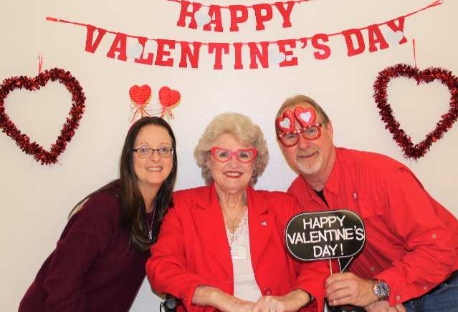

Innocent Nancy Blunk with the ‘Wild Thing ‘ Louise Coster
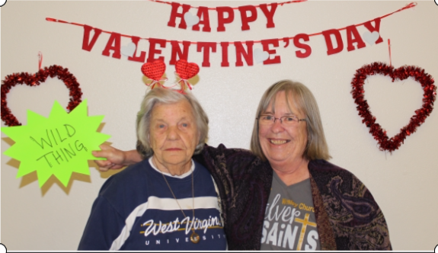

Absolutely the Loveliest Couple – Dick and LaVerne ‘LV’.
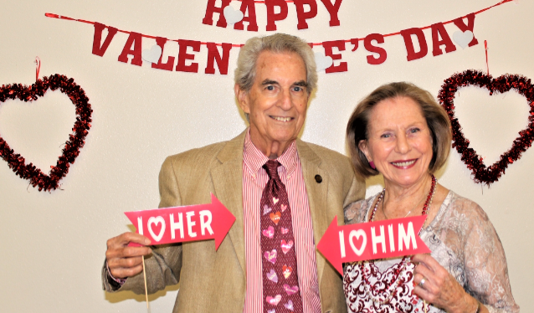

Love and Food speak the same language on Valentine’s Day – Happiness !!!
