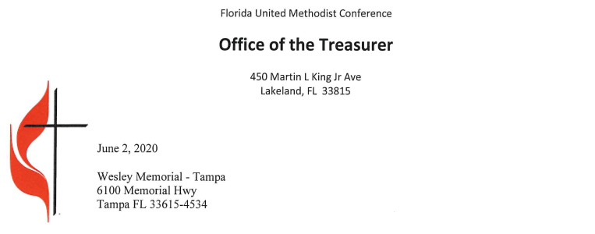
Dear Ernest M. Post Jr:

I am writing to thank you for your faithful living as disciples of Jesus Christ by giving 100 percent of your
apportionments for 2019. Apportionments are your church’s share of the funding of the budgets of The United Methodist Church around the world, the Florida Conference, and your District. These budgets are developed and
approved by our elected representatives, either as members of the Annual Conference or delegates to the General
Conference.

When every congregation contributes 100 percent of its apportionments, the entire church is able to meet its many responsibilities to mission and ministry. In short, lives are changed because of your stewardship.

- Children are fed at feeding programs;
- Young men and women receive financial assistance towards their education at Florida Southern College, Bethune-Cookman University and countless other institutes of higher education outside of Florida.
- Retreat and camp settings help grow and make disciples of Jesus by offering invitations to go further in understanding of being a Christian;
- New churches are planted;
- Existing churches are transformed to better meet the needs of the community.

In 2019, conference churches contributed $17,901,729 to the overall apportionment total of $20,474,719 this represents an 86.43 percent level of giving. This was not done without sacrifice.

Over the years, I have learned that a sign of a healthy congregation is full support of the rest of the connection. You are the ones who have a joy in God’s gifts, given in abundance, and who are practicing a spirit of generosity that points to a larger vision of the Church as a communion of congregations in common mission and ministry to the world. We appreciated all of you continued support in the current difficult times and pray that you and your congregation continue to thrive.

I hope you will pause in one of your worship services and share this letter with the people who made this 100 percent level possible. It truly is a sign of the living God at work in your midst.

May the Spirit of God continue to illumine, guide, and empower you to be God’s own people.

