A Blast of Fun at Mobbly Bayou Wilderness Preserve
First of All - - Thank you, Wesley family, for all of your support this past year!

A special thank you to adult volunteers: Paula Walker, Marilyn Preston, Ashley & Ryan DeWeese, Tonya Torres, Claudine & Phil Leauthaser, Betsy, Jim & Tommy Danielson, Jeff & Terri Davis, Danny Scherber & Jennifer Foster, Pastor Ernie, Women of Wesley & Men of Wesley for an amazing first year in this ministry. TOGETHER with the help of JESUS, we made this a year that the students will remember for a lifetime.

Without a doubt, we had blast at Mobbly Bayou Wilderness Preserve!
God blessed us with a beautiful day! So, enjoy the pictures.

We took full advantage of the park and we were able to stay safe & follow guidelines
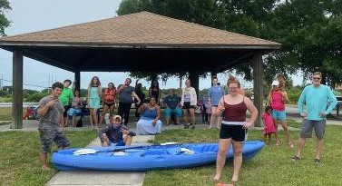

The students were so happy to get out of the house & be together in fellowship.
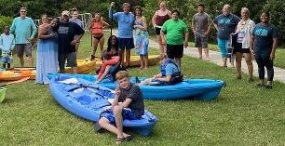

We had 5 students & 1 adult that had never been kayaking before! Fears were faced! And lots of fun
was had!
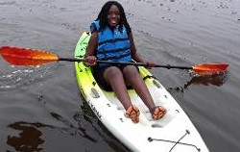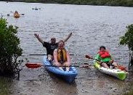

We are the change in this world!
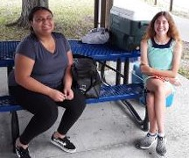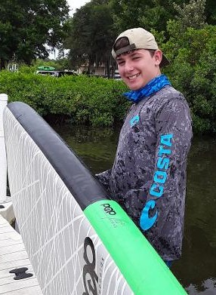

God bless you Wesley family!!

