Biography
Jeff Davis
Praise Team Guitar Player, Worship Service Guest Preacher and Teacher, SPR Member
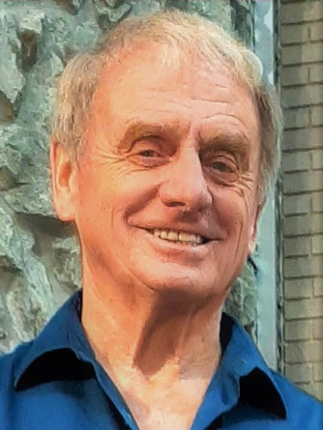
I am originally from Dayton, Ohio.
Basically, I was a church kid, but that doesn't mean I was always a Christian. My Dad died when I was ten. With just Mom and me, the church youth group became my "family." Like a lot of kids about 18 years old, I went through a period of searching. The church I grew up in was big – something like 3000 members.

The church’s Youth group was also big in the 60's - maybe 100 kids on Sunday night. But not everyone was friendly to me until one day a girl at work asked me, "Why don't you try my church?" North Riverdale Grace Brethren Church was different from Shiloh Congregational Church. They taught and believed the Bible in a way I had not heard of before. One night after youth group, the leader cornered me alone, asking if I had ever accepted Jesus as my personal Lord and Savior. I had never heard this before. He finally led me in what is often called the prayer of salvation. I went into the prayer, not sure about all this new stuff, because it was new stuff to me. But halfway into the prayer, I remember deciding to really mean it.

That was the moment when I felt a change. The Holy Spirit entered my life at that moment and my Christian life began. A lot of things changed. Prayer became easier, the Bible became easier to understand and retain. Within a year, I was feeling called to the Ministry.

I received my M.Div. from United Theological Seminary in Dayton in 1977, pastored in the United Church of Christ, The Grace Brethren Church and was Executive Director of Dayton Youth for Christ. I then came to Florida to assume the Directorship of Tampa Bay Youth for Christ in 1985. I am currently ordained by the National Association of Christian Ministers.

During the 90’s, I taught Sunday School at Tarpon Springs United Methodist Church. While I was filling in as pastor at St. Mark's UMC in Pinellas Park in the late 90's, the praise band ministry was really taking off. Guitar had been a hobby since the late 60's and praise band has now been a part of my life for the last 22 years. I believe this is a valuable ministry due to the high quality of new music being written that sincerely glorifies Christ. That’s why you can see me on most Sundays during our second service, "picking and agrinning", so to speak.

During this period, Terri and I met in 1999. She had a Y2K New Year’s Eve party that year and I happened to get an invitation. We began dating in March and got married on January 21, 2001. It's been a great 19 years and we look forward to more, Lord willing.
We have been with Wesley since 2008 and are excited about future ministry at our church.

