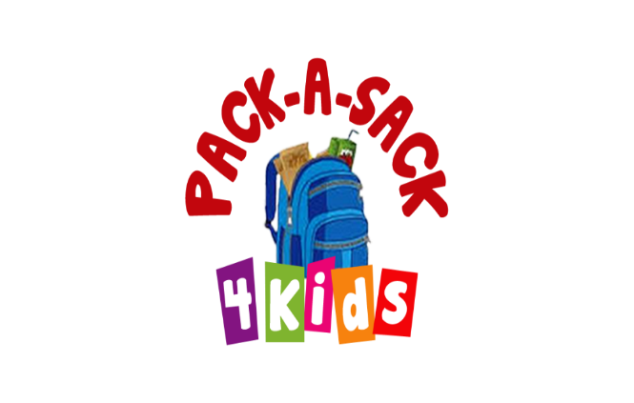
HOLIDAY FOOD DRIVE
If your place of business is interested in having a food drive during the holiday season, I’d love to help you coordinate that with needs, information on the ministry, etc.

Last year, the Pinellas County Property Appraisers office collected needed items and it was an overwhelming success. Ascensus continues to collect items for Pack a Sack year round and we are so grateful. Community Montessori also collects throughout their school year.

It’s amazing how much just a few juice boxes and chef Boyardee really helps restock our shelves. So, if your place of business is interested in helping and collecting a few items during the holiday season, just let me know…I’m happy to help.

Jamie 813/967-3800 (text or call) or by email – jamiewas@tampabay.rr.com

