METHODISTS UNITED IN PRAYER
MEDIA LUNA METHODIST CHURCH
Sierra Maestra Methodist district- Granma province, Cuba

Since 1997 Methodists United in Prayer has been a ministry of covenant relationship between the Florida Conference and the Methodist Church in Cuba. To date, Florida Methodist churches have made sister relationships with over half of the 433 Methodist churches in Cuba. This is a ministry of prayer and fellowship with our Cuban sisters and brothers. Every year many go on missions trips to their Cuba sister churches and Cuban pastors visit Florida churches.
Recently, the women at Wesley church decided to establish a relationship with the Media Luna Methodist Church by adopting its pastor, one of the ministry’s programs. There is also a commitment from both churches to pray for each other once a week. Medicines and other items are being sent to Cuba with caravan (mission trip) members.

Media Luna was the farthest mission of the Niquero Church (about 15 miles away). Missionary Rolando Suarez and his wife, Evora, had started visiting and evangelizing in that town, years ago, and felt that was where the Lord was sending them to spread the Word of God.

In the year 2000, because of the great travel difficulties to get to the mission, Niquero’s pastor was able to buy a small house in Media Luna (with a donation from Bayshore UMC) where Rolando and Evora could move and live as full-time missionaries. Many repairs had to be done to make this a livable house church

In the 2003 Annual Conference of the Methodist Church in Cuba, Media Luna was appointed an official church of the Methodist Church in Cuba. Although all of those who come to the services tithe faithfully, their income is very meager.

After several pastoral changes, in the 2016 Annual Conference, Misleidis Mendoza was appointed pastor of Media Luna church. Pastora Misleydis and her husband have no children; they have 3 nieces and nephews whom they love as their own. Currently the church has about 70 members. Many more attend Media Luna small house church weekly to worship.

MEDIA LUNA (Half Moon) METHODIST CHURCH

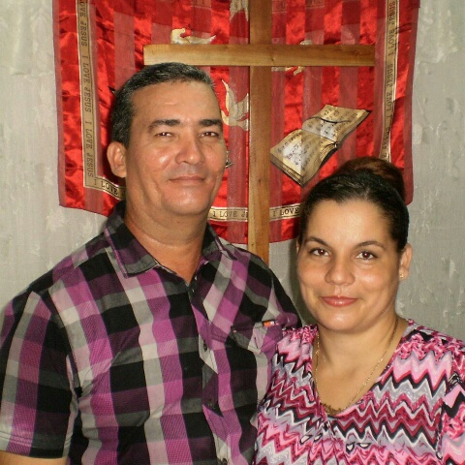
Pastora Misleydis Mendoza and her husband

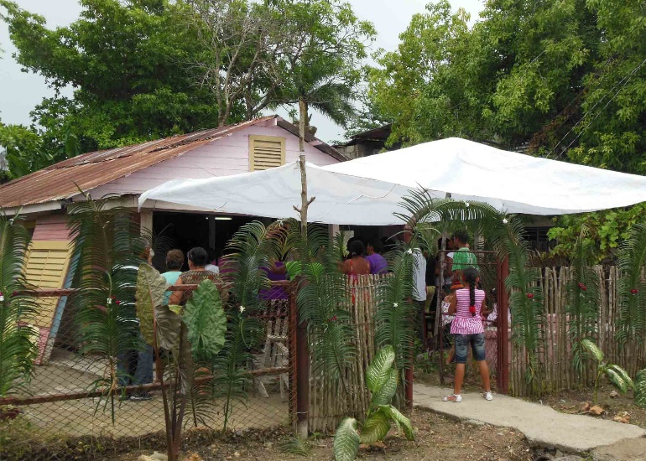
Media Luna house church had to place a covering on the front yard to accommodate all the attendees

For more information about the Florida Conference ministry in Cuba go to www.flumc-mission.org and click on Cuba
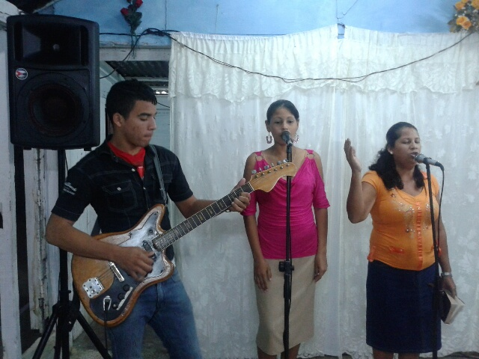
Part of the Worship Team

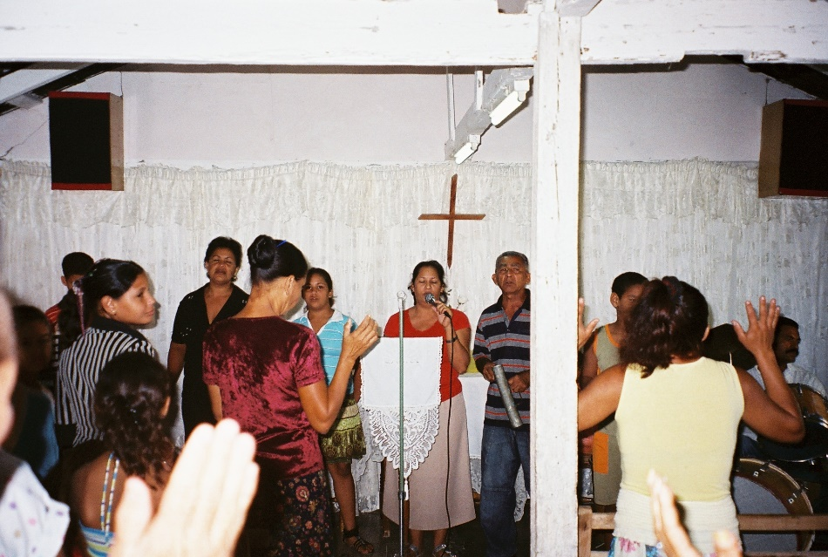
Services are conducted on the front part of the pastoral
home. The family lives in the back. Benches and altar items and musical instruments were donated by other
local churches.

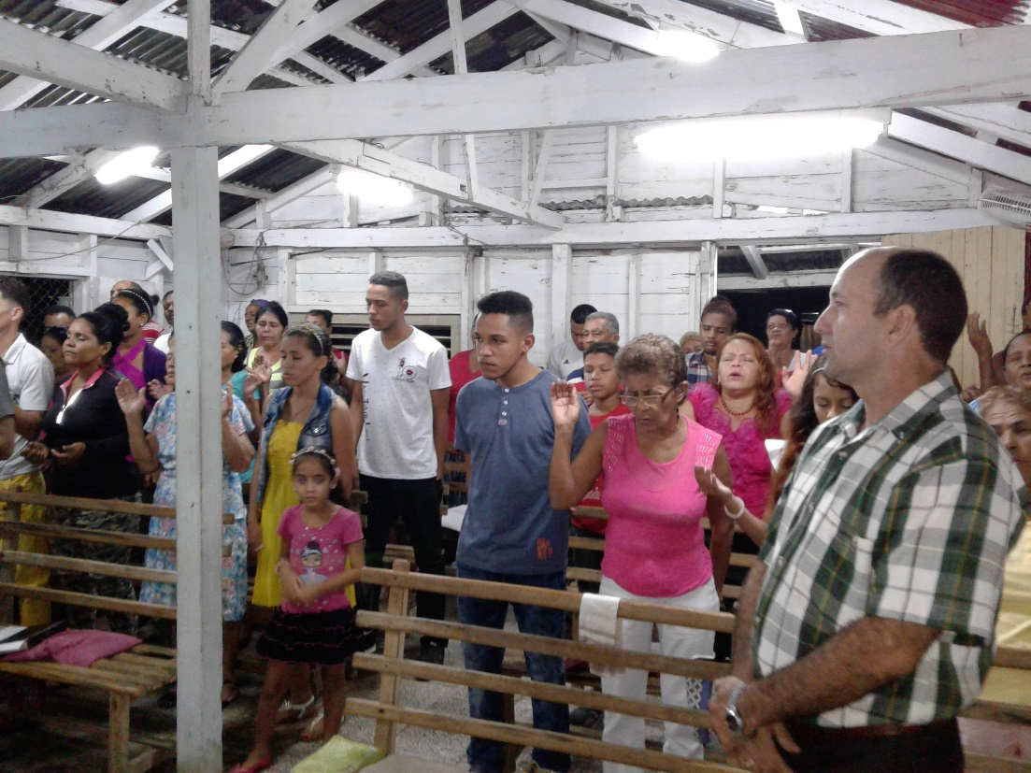

Congregation worshipping

